**TASK 3**

**1. Write a program in python to find out LCM of two numbers.**

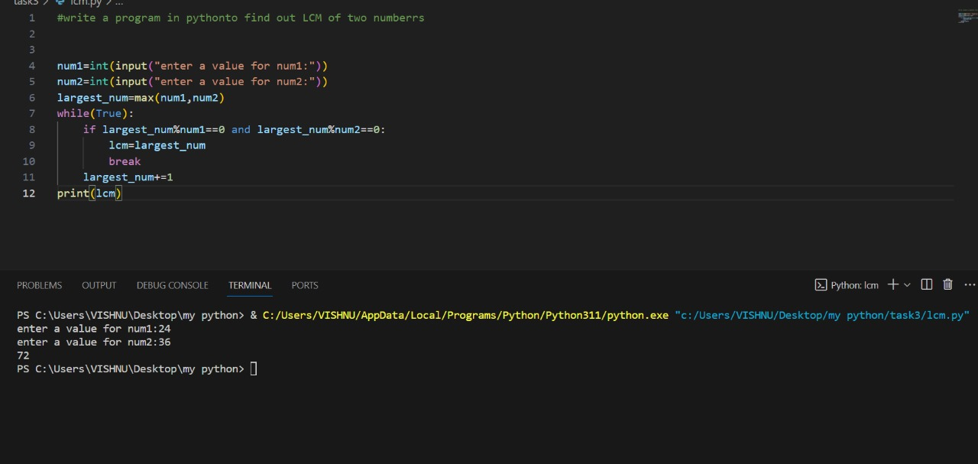

**2. Write a program in python to find out the factorial of the number.**

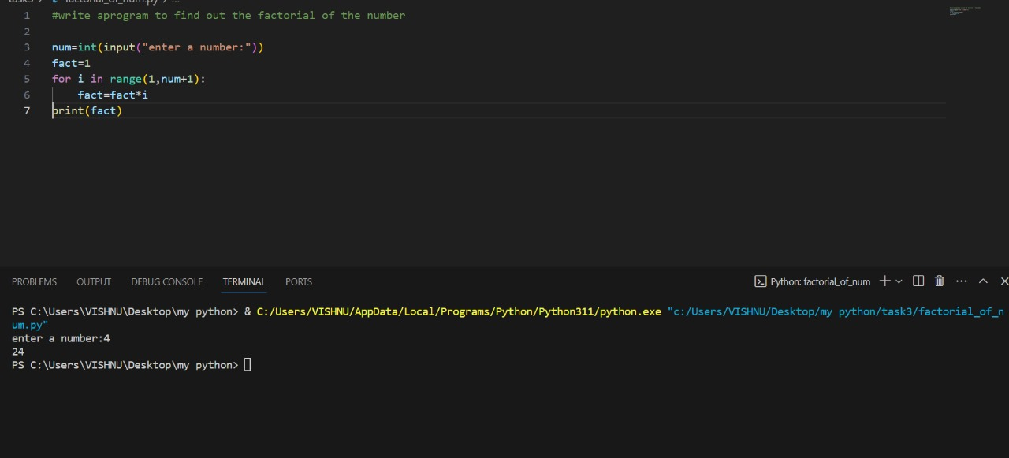

**3. Write a program in python to find out the HCF of two number.**

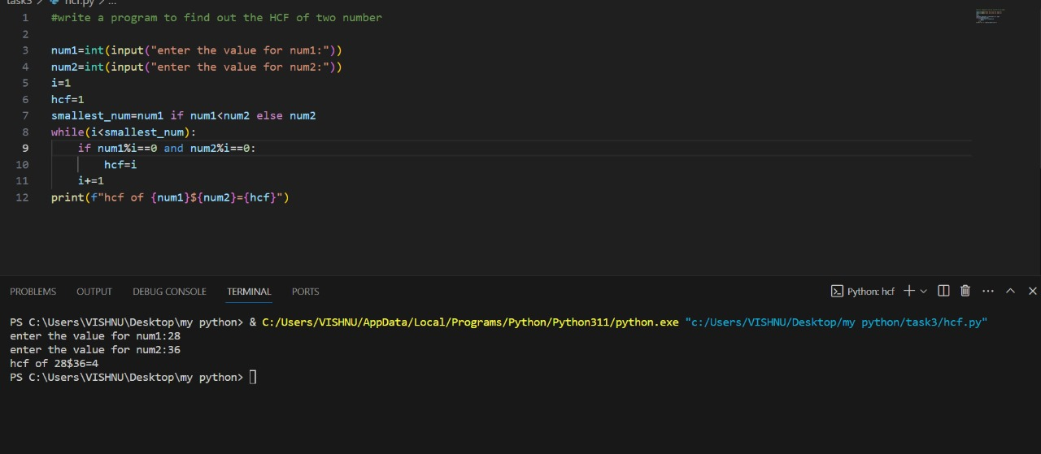

**4. Calculate the sum of numbers from 1 to 10 using a for loop.**

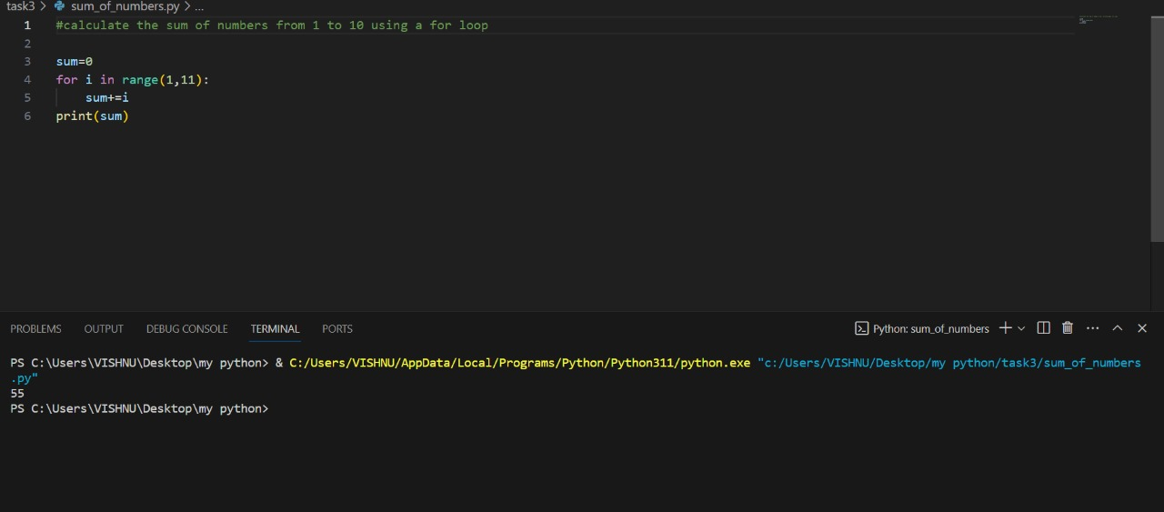

|  |
| --- |
|  |

|  |  |
| --- | --- |
| |  | | --- | | **5. Print numbers from 1 to 5, expect 3 using a for loop.** | |
|  |